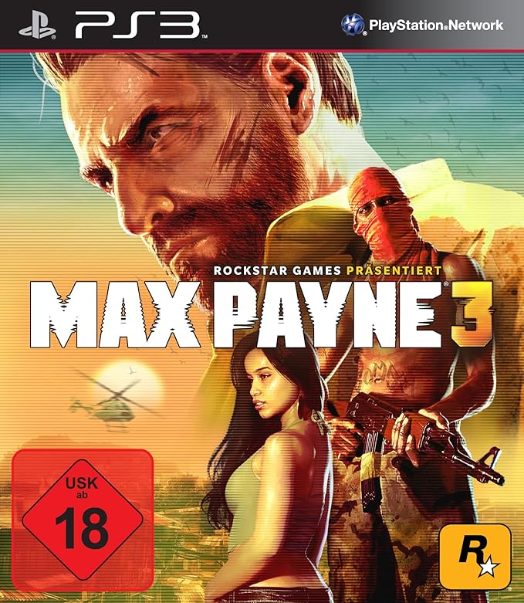

Max Payne 3:

**1️. Gritty & Emotional Storyline**

Follows **Max Payne**, now a **bodyguard in São Paulo, Brazil**, battling **crime, corruption, and his own personal demons**.

**2️.Signature Bullet-Time Mechanics**

Features the iconic **slow-motion gunplay**, allowing for cinematic, action-packed combat.

**3️. Realistic Combat & Smart AI**

Uses **advanced physics, motion capture, and intelligent enemy AI** to create **dynamic and intense shootouts**.

**4️.Multiplayer Mode with Unique Features**

Includes online **Gang Wars and Payne Killer modes**, incorporating **Bullet-Time into multiplayer battles**.

**5️. Cinematic Presentation & Strong Visuals**

Seamless **cutscenes, realistic animations, and stunning graphics** enhance the **noir-style storytelling**.